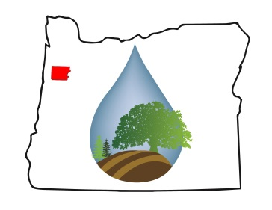
POLK SOIL AND WATER CONSERVATION DISTRICT BUDGET COMMITTEE AGENDA
May 13, 2020
6:00 PM–8:00 PM
Via Zoom Conference
https://us04web.zoom.us/j/235073671
Meeting ID: 235 073 671 Password: 970474
Phone in @ +1-253-215-8782 US

TIME TOPIC WHO ACTION

6:00 PM CALL TO ORDER Polk SWCD Chair

6:01 PM Introduction of Budget Committee Woods

6:05 PM Election of Budget Committee Chair & Secretary Woods VOTE

6:10 PM Approval of May 16, 2019 Budget Committee
Minutes (attachment A)
Committee
Members
VOTE

6:15 PM Duties of Budget Committee (attachment B) Budget
Information

Committee Chair

6:20 PM Presentation of the Budget Message (attachment C) District
Information

Manager
Karin Stutzman

6:25 PM Public Comments Public

6:45 PM Presentation of Budget (attachment D) Woods
Information

7:15 PM Budget Deliberations and Action
- General Fund
- Special Projects Fund
- Cornerstone Property Fund
- Smithfield Oaks Property Fund
- Resolution Adopting the Budget – 1st Reading is the committee’s deliberation

Budget Committee Members

VOTE

8:00 PM Adjourn Budget Committee
Chair
OR if needed Continue Budget Deliberations at 2ND Budget Committee Meeting
May 20, 2019 at 6:00 PM

Location: Zoom Meeting TBD

The Polk Soil & Water Conservation District is an equal opportunity provider and employer which complies with the Americans with Disabilities Act (ADA). If you need an accommodation to participate in this event, p leas e contact us at (503) 623-9680 or by email at polk.swcd@polkswcd.com 48 hours prior to the event date.

